
Adding and subtracting surds

Geometry was used extensively by the ancient Egyptians. They took great care in determining the directions north, south, east and west. North–south orientation was obtained by finding the direction of the noonday sun, or by using the rising and setting positions of a star. A star rises in the east and sets in the west, giving the east–west axis. True north can be obtained by bisecting the angle formed on the horizon by the two points.
Why was this information required by the ancient Egyptians in the construction of the pyramids?
Find out the answer by solving the following, showing all your working in the space provided. Write the question’s code letter above its solution in the tables on the next page.
Simplify each of the following.
D 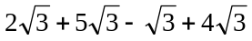 | E 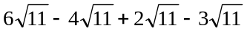
O 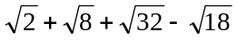 | C 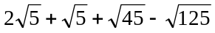
M 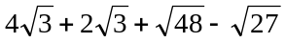 | F 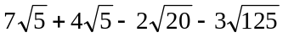
S 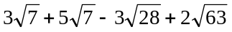 | N 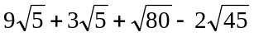
P 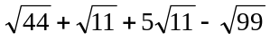 | H 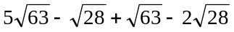


U 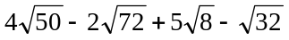 | T 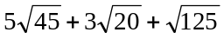
I 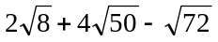 | R 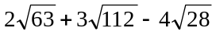
A 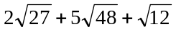

Why was this information required by the ancient Egyptians in the construction of the pyramids?
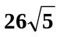 | 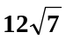 | 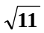 |  | 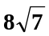 | 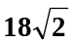 | 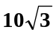
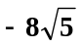 | 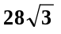 | 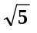 | 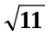 |  | 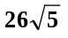 | 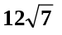 | 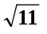
-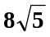 | 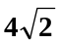 | 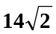 | 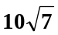 |  | 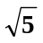 |  | 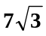 | 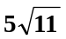 | 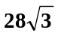
 |  |  | 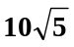

Adding and subtracting surds
Answers

D: 10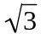, E: 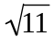, O: 4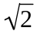, C: 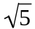, M: 7, F: -8, S: 8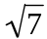, N: 10, P: 5, H: 12,
U: 14, T: 26, I: 18, R: 10, A: 28

THE SIDES FACE THE FOUR COMPASS POINTS

